2446532

Max Kruger

Game Prototype 2 Design Document

## Defining Idle Clicker

An idle clicker game is a genre of games which all involve the management of revenue streams. Their main mechanic is clicking which in turn gives the player a specific amount of this revenue. The player can then spend their revenue on upgrades that all involve increasing the rate at which the player earns. Some games like clicker heroes use a primary currency converter. This is another currency that is converted into the game's primary currency through an action, like killing an enemy. In clicker heroes, players' damage per second is converted into gold by killing an enemy.

## A genre analysis

In my game Blood Battle I have used cookie clicker and clicker heroes as inspiration. In cookie clicker the player clicks on a cookie to earn 1 cookie. A core system in the game is once the player has earned enough cookies, they can buy a cursor which automatically clicks on the cookie for the player. Over time, these cursors increase the amount of cookies earned per second. Another mechanism in the game is the grandma system. This system allows for players to purchase a grandma which will produce a certain amount of cookies per second. Furthermore, this increases the player's cookie revenue per second. The game also uses a shop system where players can sell items for cookies in case they want to buy an upgrade. Overall, the game has 266 total building upgrades that increase the grandma's efficiency and ultimately increase the amount of cookies earned per second. Similarly, in clicker heroes, players kill enemies by clicking on them. They can purchase upgrades which increases the amount of damage each click does. Damage per second is measured and then rewarded to the player as the primary currency once a monster is killed. Furthermore, autoclickers can also be bought, but in clicker heroes they are adventurers and warriors that click for you. Auto clickers are a core system in every Idle clicker game, hence the name. Clicker Heroes also has a level system. Each level presents harder enemies which have more health that also have more reward. As you upgrade your clicks and levels become easier, more levels unlock. In my game players will have to actively strategise their next move. Like a Turn based RPG one might have abilities that increase armour or attack for their characters. In Blood Battle, players can increase their own armour or attack if they have the resources (like mana in an RPG).

## Design Goal & Question & Interrogation

My Design Goal for Blood Battle was to experiment with my understanding of an idle clicker by creating something more tense and requiring players to think. To take an alternate route to Idle clicker games. My Design Question is: Can I create an Idle Clicker where players feel more tense and must strategise in order to survive. I find idle clickers to be almost pointless. Once you have upgraded everything there is to upgrade in cookie clicker, then what? I find that the point of an idle clicker, to earn revenue, was not fulfilling enough for me. I wanted to experiment and find something that had a challenge that wasn't completely based on the player spending hours clicking on something. So I thought to myself what if the player could be clicked on too? I used inspiration from clicker heroes and created a health bar for the player and a health bar for enemies. I made a similar system to clicker heroes in which the player clicks on an enemy to do damage, but also gains revenue from every click, just like cookie clicker. The twist is for every second that passes, the enemy depletes the player's health. This means that the player will lose if they are not aware and are not making necessary upgrades to stay alive. Once the player kills an enemy, it heals the player for a specified amount. This creates a whole new thought to the game. Strategy.

The player has to actively and quickly make upgrades and decide what to upgrade to stay alive. The game includes core systems of idle clicker games like auto clickers, multipliers, upgrade systems, and revenue from clicking. In Blood Battle you level up as you defeat monsters, which in turn spawns more difficult monsters that do more damage and give you more rewards, similar to clicker heroes. Lastly, this addition of a player health bar added a new upgrade that is seen in a lot of RPG games, armour. Players can upgrade their armour as a multiplier. So every time an enemy attacks, armour is accounted for. The calculation is as follows: Player Health - (Enemy base damage - (enemy base damage * armour multiplier like 0.05)). This adds more strategy as players can choose to put more resources into defense(armour) rather than offense(auto clickers), allowing for more sustainability.

## Design notes & Process

However this was not the only problem that I encountered and managed to fix. As I previously mentioned, I do not like idle clickers' missions of simply getting revenue. So I decided to challenge my own understanding of idle clickers and what they could possibly mesh with in terms of other genres. I wanted more strategy involved in my game. I wanted the player to have to think before purchasing certain upgrades. The player health bar created consequences for not having certain upgrades at certain levels and as the game became more difficult (See image 1 below section). Then came the requirement for a primary currency converter. I thought quite long on this since I wanted to make it unique to the games theme of blood and monsters. Monster hearts seemed to fit the idea of blood since hearts function is to pump blood. I decided to have 2 groups of upgrades, one costs blood and the other costs hearts. Blood was used to purchase more clickers and hearts was used for damage and armor modifier upgrades. (See image 2 below section)

Balancing currency, damage and health was the most challenging part of this game which ultimately took the most amount of time in creating this game. It was easy to find the problems, but difficult to find the solutions. Often I wasn't sure if buffing damage or health, or cost would fix a balance issue. But, I soon learnt that just changing them all one by one and testing them was the best way to figure it out. From this I got the idea to make 3 different versions of my game each with a different solution and gave my friends each a different copy. Thankfully I found the solution with their help. Furthermore, balancing where my major economic steps were, was hard because I didn’t want my player to play my game for an hour. I wanted them to play for 10-15 minutes. This meant that the solution was not making the players level up to level 50 quickly, but rather drag out each level, make the levels more impactful by adding different enemies that granted different amounts of rewards and decrease the level cap to less than 20 (See Image 3 below Section). This caused more issues since I needed to rethink my game's pace and difficulty with each level. This was another timely process. I just needed to calculate the percentages that would increase in the enemy’s stats with every level and then implement them to drag out the levels. In the end all I needed was a modifier to work with and then I could easily create 13 player levels that are balanced.

Unfortunately this leads to a problem. After trying the solution above I found that since I created the game and played it 100 times, I knew the best way to go about every level and the best upgrades to get at every level. But my friends didn't know. After they playtested, none of them could complete the game. They lost health too quickly after level 4. This was the most challenging balance I have had to make so far. I thought long about it. I thought that instead of changing the enemies damage to the player, let me increase the players health every so often (4 levels) and create an enemy that would heal the player instead (See Image 4 in section below). This actually worked amazingly and solved another problem that I didn't even realize. The last problem I faced was that the player would have to stop clicking on the enemy in order to buy items which could lead to them losing more HP than they would like to since they would kill the enemy slower. But the healing enemy which is a heart gives the player time to stop and let the auto clicker kill it while they get ready for the next enemy, allowing them to strategize, upgrade, or just take a break. IT WORKED! This was an amazing solution to fix 2 problems. Overall, I learned a lot. Most importantly, I learned how to find different approaches to different problems. The best solution is one that can fix many problems.

Design Section Images

Image 1 Health Bar - Player Health bar



Image 2 - Shop design split into blood section on the left and heart section on the right.

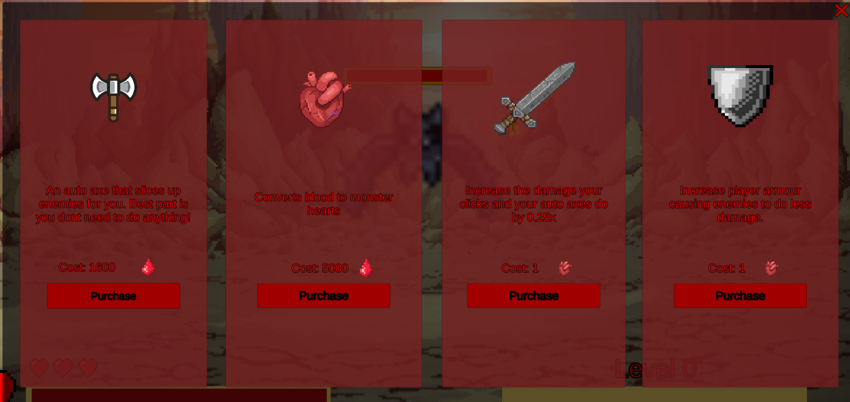

Image 3 - XP modifier used to calculate the max XP of the next level, this drags out each level further and further every level.



Image 4 - Heart enemy that when killed, heals player for specified amount of HP, balances out difficult levels

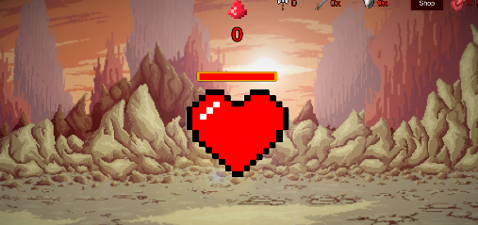

## Reflection

My original goal was to create an idle clicker game that had a strategy to it to create a more tense gameplay for the player. I can successfully state that this experiment was successful. Blood Battle successfully keeps a player on their toes through the use of the player health bar and enemies but keeps its integrity as an idle clicker thanks to the core systems implemented. The game is still naturally an idle clicker. You can purchase auto axes that are the auto clickers, the game ‘s main driving force is currency that is incremented thanks to upgrades and the player. With these revenues the player must constantly make smart decisions as to where they want to invest their money in order to progress further and further until they win or lose. The game has replayability since the player can use different strategies in order to try to beat the game.

Creating this game taught me so much about currencies in video games. Currencies was something that I thought would be the easiest thing to do in a game. I thought of them as a simple variable you increase when something happens in a game. But, creating a currency heavy game like a 2D clicker has made me realize how deep and complex a currency system can really be. At first I just pulled numbers from thin air and was not using any complexity of calculations. However, soon I realized that it was not a sustainable way forward for my game since it had many levels that needed more and more numbers. After finding my problem I decided to base almost all of my numbers off of a calculation so that the way forward was not as hard, plus I could modify my calculation at any point if I needed to balance something. This was definitely a massive time saver and made the game easier to test and configure.

Creating the player health bar as seen previously in Image 1 in the design process was a really fun twist to experiment with for an idle clicker. It created many problems but also many learning experiences on what game developers have to go through daily to figure out how to solve currency or balancing problems. It gave me an opportunity to fiddle with calculations and fine tune enemies to make the game truly feel challenging and engaging. Overall, I find that my experimenting was successful. I have made a Strategy Idle Clicker game that keeps players on their toes, paying attention, whilst still holding its integrity of an idle clicker.